State Space Control of the Helicopter Model

Joseph Le

AAE 364L

19 November 2021

TA: Himal Sapkota

1 – Introduction

1.1 – Objectives, Goals, and Purposes

There are two parts of this lab, the first part is to control the helicopter model with an error feedback model and the second part was to control the helicopter model with state feedback model. The overall goal is to observe how the different state space control methods affect the performance.

1.2 – Intended Methods

To achieve the objectives, the performance of each method will be recorded and compared against each other. The inputs for the error feedback controller include the voltages which are determined by the error between the desired angles/rates and the actual. Similarly, the inputs for the state feedback controller include the voltages, but this time are determined by state of the model at a certain time.

2 – Procedure

2,1 – Definition of Variables

2.2 – Schematic and Description of Apparatus

Figure 1 – Helicopter Model Apparatus

This lab makes use of a model helicopter that is set on a 2 degree of freedom mount which restricts movement of the helicopter to only pitch and yaw movements. The inputs into the apparatus is the voltage coming from the power supply and the output is the rotation of the rotors which pitch and yaw the model helicopter.

* 1. – Procedure of Experiments

Part (i) – Error Feedback

1. Run setup files and open Simulink for error feedback, prepare the recording of states

2. Enter Ki from the prelab for the error feedback controller

3. Disable the joystick

4. Set input to sine wave pitch with 15 degrees for pitch and 30 degrees for yaw and all other gains to 0

5. Run simulation and tune control gains until performance is reasonable

6. Save results

Part (ii) – State Feedback

1. Run setup files and open Simulink for state feedback, prepare the recording of states

2. Enter Ki from the prelab for the state feedback controller

3. Disable the joystick

4. Set input to sine wave pitch with 15 degrees for pitch and 30 degrees for yaw and all other gains to 0

5. Run simulation and tune control gains until performance is reasonable (repeat 2-4)

6. Save results

3 – Results

a)

Error Feedback Gains

State Feedback Gains

b)

|  |  |  |
| --- | --- | --- |
| Variable | Error Feedback | State Feedback |
| L2[e]pitch [deg] | 1.0735 | 3.3386 |
| L2[e]yaw [deg] | 1.7334 | 5.8899 |
| em,ss,pitch­ [deg] | 2.4398 | 5.5820 |
| em,ss,yaw [deg] | 4.6100 | 11.4508 |

4 – Analysis and Discussion

The equations of motion for the model helicopter are the same as they were from the last lab and can be seen below:

Figure 1 – Nonlinear Equations of Motion of the Helicopter Model

Figure 2 – Linearized Equations of Motion

The assumptions that were made are that the angles and rates do not go too high such that the system is still near the linearization points. It is also assumed that the function between the voltage and the force output is linear and multiplied by the gains. It is also assumed that the pitch and yaw moments of inertia are equal. The equilibrium points for the yaw angle are at any point because the yaw angle will not cause instability in the system. On the other hand, the equilibrium point for the pitch is at -0.5185 radians. The states are the pitch, yaw, and their angular rates. The state space model takes the linearized equations of motion and puts them into matrices seen in figures 3 and 4.

Figure 3 – State Space Equations (without controller)

Figure 4 – State Space Matrices (with controller)

A =

|  |  |  |  |  |  |
| --- | --- | --- | --- | --- | --- |
| 0 | 0 | 1 | 0 | 0 | 0 |
| 0 | 0 | 0 | 1 | 0 | 0 |
| .3,6162 | 0 | -.2 | 0 | 0 | 0 |
| 0 | 0 | 0 | -.1325 | 0 | 0 |
| 1 | 0 | 0 | 0 | 0 | 0 |
| 0 | 1 | 0 | 0 | 0 | 0 |

B =

|  |  |
| --- | --- |
| 0 | 0 |
| 0 | 0 |
| .7756 | .0827 |
| .1546 | .1725 |
| 0 | 0 |
| 0 | 0 |

Where the A matrix is the 4x4 matrix that is multiplied by the x vector and the B matrix is 4x2 matrix that is multiplied by the voltage vector. The control schemes, error feedback and state feedback, utilize the state space system in two different ways. The error feedback takes the error from the actual output and the reference input to drive the system, while the state feedback just gives the state of the system to make new adjustments.

Controller Performance

Error Feedback -

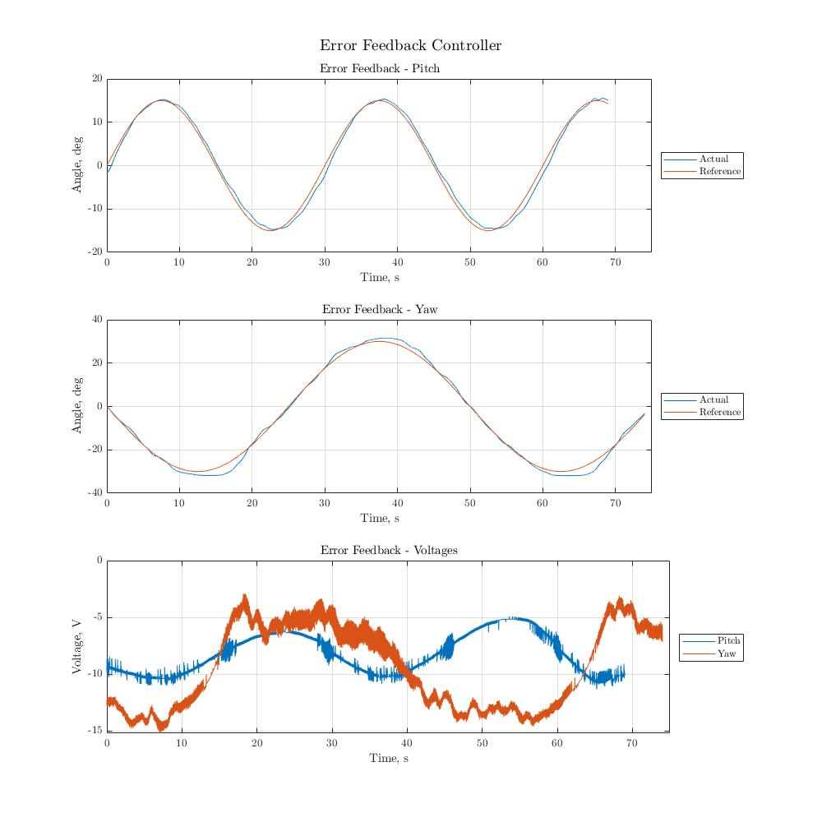

Figure 5 – Error Feedback Controller Results

State Feedback Controller

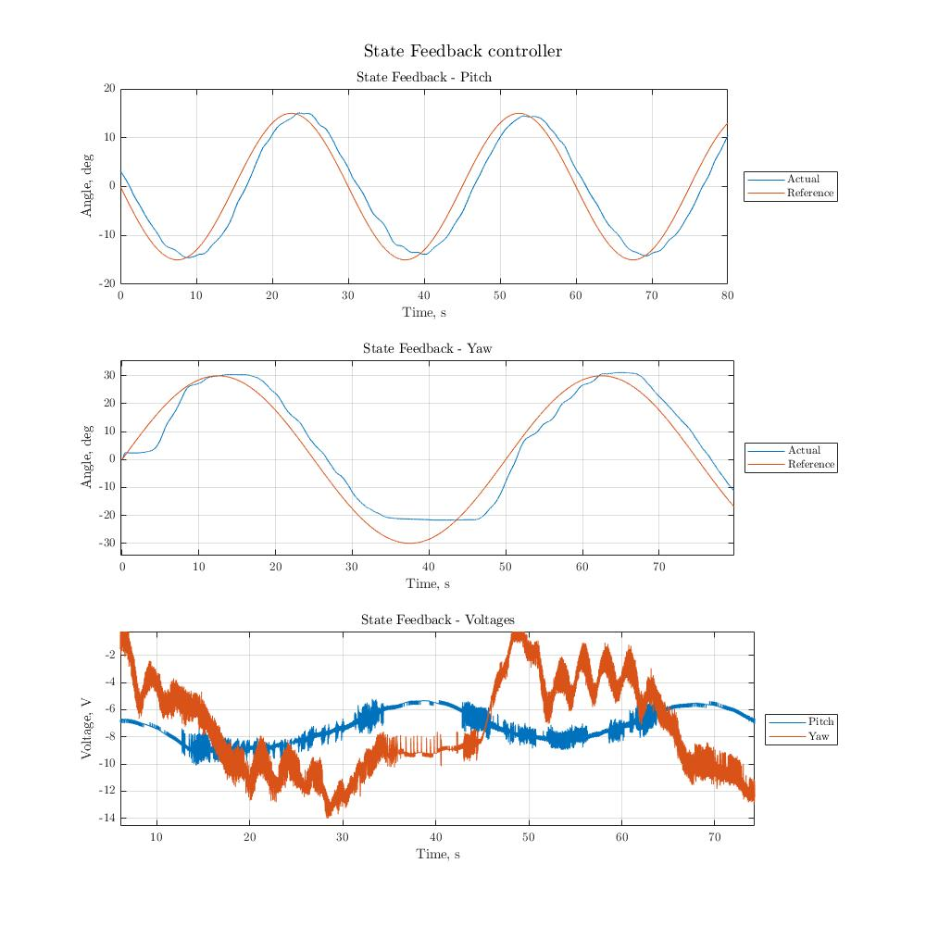

Figure 6 – State Feedback Controller Results

When looking at the voltage plots for both controllers, it can be seen that there is no saturation problem with the pitch data. However, there seems to be some or near saturation for the yaw motor as it seems not to go for below -15 volts on either graph. If there was saturation in the system, it would cause the helicopter to not be able to follow the reference signal properly which can be seen in the yaw angles in the state feedback plots.

Controller Comparison

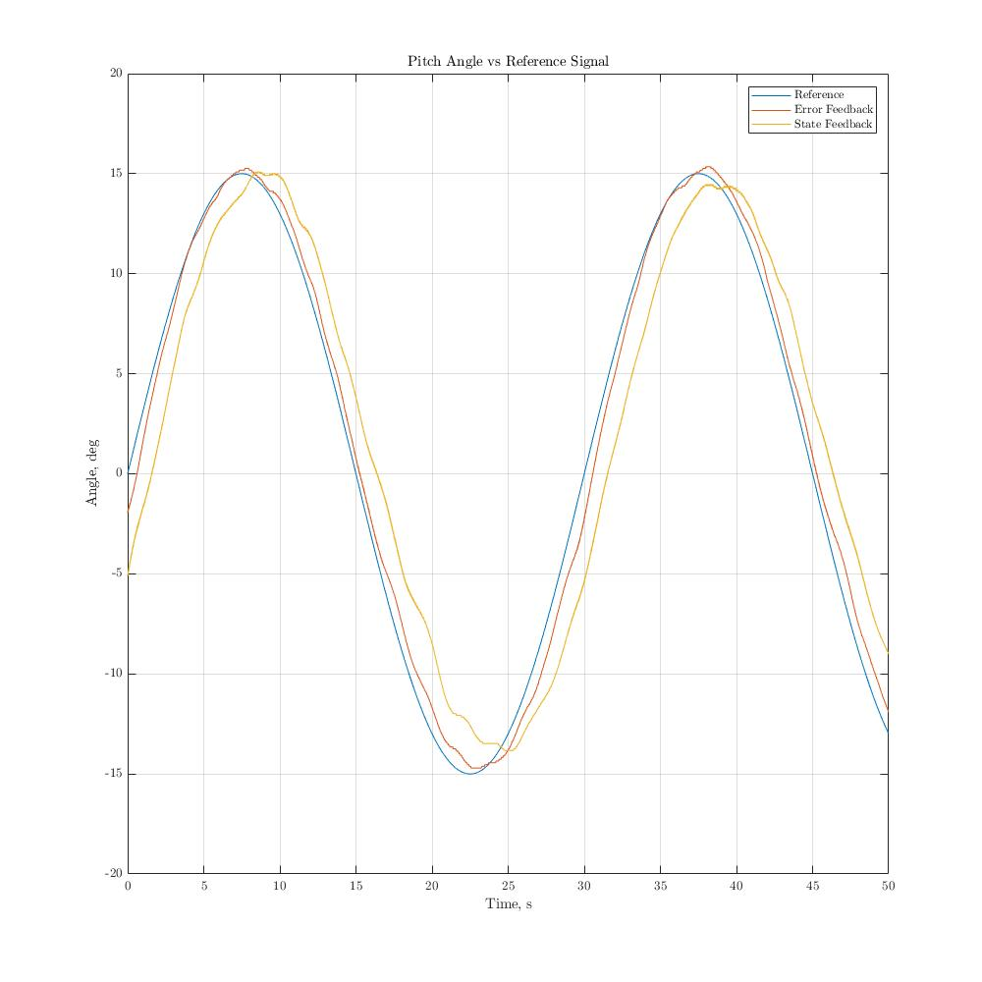

Figure 7 – Pitch Controller Comparison

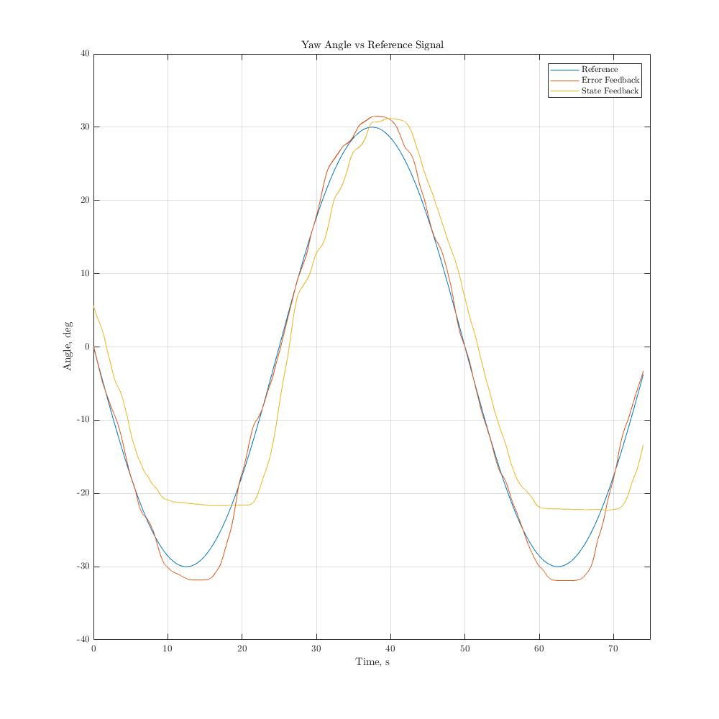

Figure 8 – Yaw Controller Comparison

Comparing the two different controllers, it can be seen that the error feedback control scheme performs much more accurately and faster than the state feedback controller. This can be quantified using the two performance criterion: L­2[e], the average tracking performance, and eM,ss, the maximum absolute steady state error. This can be seen in the results section where the L­2[e] performance for the error feedback was 1.0735 degrees and 1.7334 degrees for pitch and yaw respectively and the eM,ss being 2.4398 degrees and 4.6100 degrees. For the L­2[e] performance for the state feedback was 3.3386 degrees and 5.8899 degrees for pitch and yaw respectively and the eM,ss being 5.5820 degrees and 11.4508 degrees. These results give us that the error feedback controller performs much better than the state feedback controller.

5 – Conclusions

5.1 – Main Points

In this experiment, a helicopter model was controlled using a state space method with two different types of controllers: an error feedback controller scheme and a state feedback controller scheme. It can be concluded from the data that error feedback controllers perform noticeably better than the state feedback controller, with overall error being lower and better average tracking. Overall, performance was acceptable with both controllers as they followed fairly closely in magnitude, frequency, and phase.

5.2 – Limitations

A large assumption that was made for this experiment was that the equations of motion were linearized about a point. This means that the further the motion of the system deviates from the equilibrium point, the more inaccurate it will be. Some limitations during the experiment were the high amount of noise in the data, this causes small orders of error in the final calculations. Since this is an experiment, there are responses or system properties that cannot be obtained from the data, such a response are responses that are that which are out of the scope of the maximum voltages or the physical stops on the apparatus which can both be simulated.

5.3 – Lessons

I have no suggestions for further improvement with this experiment. The lab allowed me to learn the differences between types of control schemes such as error and state feedback. I would recommend future students to study the derivations of the equations of motion and the implementation of the controllers in the lab manual and the Simulink files to gain a higher understanding of the material.